**Client Feedback – Motivation**

In order to ensure the success of our application, we must make sure that the users keep coming back and engaging with Training Guru.

After Multiple discussions with potential end users we found that the main features users found motivating are;

* Reminders
* Notifications
* Emails

Below we can see the initial plans for each of these areas. A big motivator with the clients tested with was Apple watch notifications, below (left) we can see designs for push notifications which have been inspired by these Apple Watch Notifications.

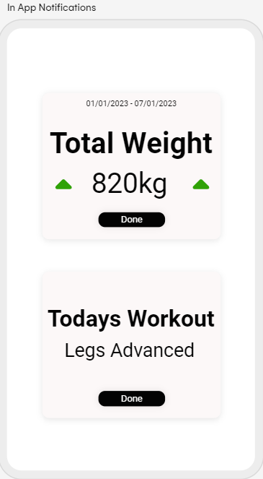

Above, the image on the right are notifications designed for display in app, these were done in association with our external Collaborator in DkIT. He drew inspiration from an application he has previously used called train heroic, which gave you a motivator of beating the total amount of weight you lifted the previous week.

On page 2 we can see an example of the email a client will receive when their personal trainer assigns them a new workout. This provides further motivation to come back and engage with the app, aswell as carrying out the plan put in place by the trainer.

On page 3 we can see the initial thinkings behind the notification the designs displayed previously.

